View this in web layout mode to get the alignment right!!

**Looks for solutions to problems**

**Excited about the job**

**No complaining**

**Wants to do well**

**Good mood**

**Researches company   
before  
interview**

**High enthusiasm**

**Positive attitude**

**Qualities that companies are looking for**

**High enthusiasm**

**Positive attitude**

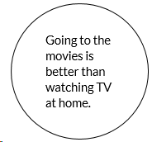

**Qualities that companies are looking for**

**Works well with others**

**Build consensus**

**Team player**

**Focus on group goals**

**High enthusiasm**

**Qualities that companies are looking for**

**Positive attitude**

**Team player**

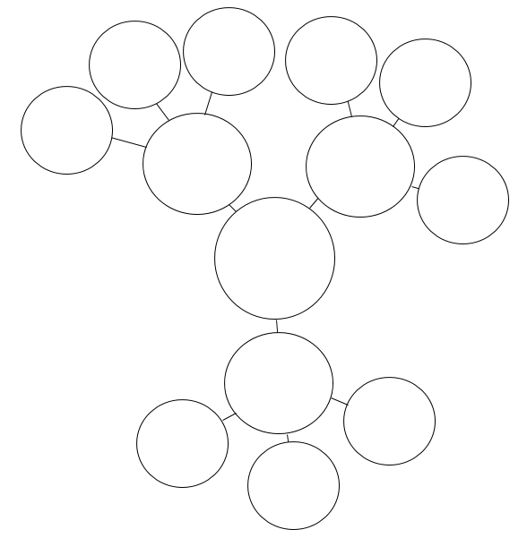

 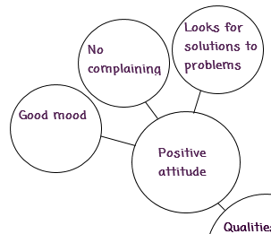 

**Your topic**